**Problem-01:**

Consider a direct mapped cache of size 16 KB with block size 256 bytes. The size of main memory is 128 KB. Find-

1. Number of bits in tag
2. Tag directory size

**Solution-**

Given-

* Cache memory size = 16 KB
* Block size = Frame size = Line size = 256 bytes
* Main memory size = 128 KB

We consider that the memory is byte addressable.

**Number of Bits in Physical Address-**

We have,

Size of main memory= 128 KB= 217 bytes

Thus, Number of bits in physical address = 17 bits

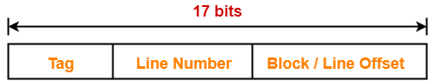

**Number of Bits in Block Offset-**

We have,

Block size= 256 bytes= 28 bytes

Thus, Number of bits in block offset = 8 bits

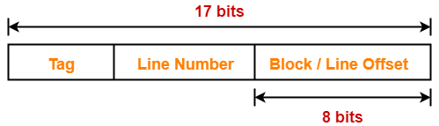

**Number of Bits in Line Number-**

Total number of lines in cache= Cache size / Line size

= 16 KB / 256 bytes= 214 bytes / 28 bytes= 26 lines

Thus, Number of bits in line number = 6 bits

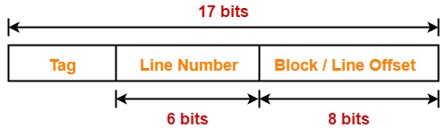

**Number of Bits in Tag-**

 Number of bits in tag= Number of bits in physical address – (Number of bits in line number + Number of bits in block offset)= 17 bits – (6 bits + 8 bits)= 17 bits – 14 bits= 3 bits

Thus, Number of bits in tag = 3 bits

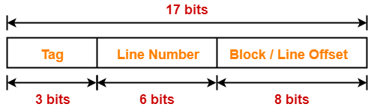

**Tag Directory Size-**

Tag directory size= Number of tags x Tag size= Number of lines in cache x Number of bits in tag

= 26 x 3 bits= 192 bits= 24 bytes

Thus, size of tag directory = 24 bytes

**Problem-02:**

Consider a direct mapped cache of size 512 KB with block size 1 KB. There are 7 bits in the tag. Find-

1. Size of main memory
2. Tag directory size

**Solution-**

 Given-

* Cache memory size = 512 KB
* Block size = Frame size = Line size = 1 KB
* Number of bits in tag = 7 bits

 We consider that the memory is byte addressable.

**Number of Bits in Block Offset-**

 We have,

Block size= 1 KB= 210 bytes

Thus, Number of bits in block offset = 10 bits

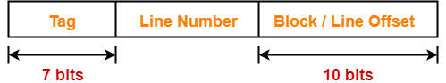

**Number of Bits in Line Number-**

Total number of lines in cache= Cache size / Line size= 512 KB / 1 KB= 29 lines

Thus, Number of bits in line number = 9 bits

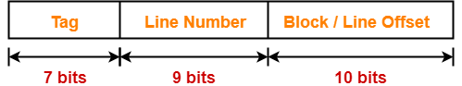

**Number of Bits in Physical Address-**

 Number of bits in physical address

= Number of bits in tag + Number of bits in line number + Number of bits in block offset

= 7 bits + 9 bits + 10 bits= 26 bits

Thus, Number of bits in physical address = 26 bits

**Size of Main Memory-**

We have,

Number of bits in physical address = 26 bits

Thus, Size of main memory= 226 bytes= 64 MB

**Tag Directory Size-**

 Tag directory size= Number of tags x Tag size= Number of lines in cache x Number of bits in tag

= 29 x 7 bits= 3584 bits= 448 bytes

Thus, size of tag directory = 448 bytes

**Problem-03:**

 Consider a direct mapped cache with block size 4 KB. The size of main memory is 16 GB and there are 10 bits in the tag. Find-

1. Size of cache memory
2. Tag directory size

**Solution-**

 Given-

* Block size = Frame size = Line size = 4 KB
* Size of main memory = 16 GB
* Number of bits in tag = 10 bits

 We consider that the memory is byte addressable.

**Number of Bits in Physical Address-**

 We have,

Size of main memory= 16 GB= 234 bytes

Thus, Number of bits in physical address = 34 bits

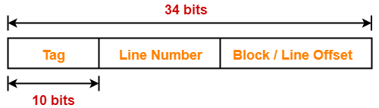

**Number of Bits in Block Offset-**

We have,

Block size= 4 KB= 212 bytes

Thus, Number of bits in block offset = 12 bits

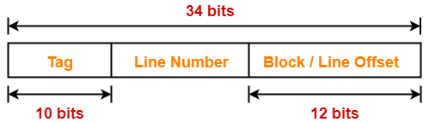

**Number of Bits in Line Number-**

Number of bits in line number= Number of bits in physical address – (Number of bits in tag + Number of bits in block offset)= 34 bits – (10 bits + 12 bits)= 34 bits – 22 bits= 12 bits

Thus, Number of bits in line number = 12 bits

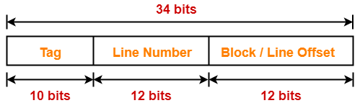

**Number of Lines in Cache-**

 We have-

Number of bits in line number = 12 bits

Thus, Total number of lines in cache = 212 lines

**Size of Cache Memory-**

 Size of cache memory= Total number of lines in cache x Line size= 212 x 4 KB= 214 KB= 16 MB

Thus, Size of cache memory = 16 MB

**Tag Directory Size-**

 Tag directory size= Number of tags x Tag size= Number of lines in cache x Number of bits in tag

= 212 x 10 bits= 40960 bits= 5120 bytes

Thus, size of tag directory = 5120 bytes

**Problem-04:**

Consider a direct mapped cache of size 32 KB with block size 32 bytes. The CPU generates 32 bit addresses. The number of bits needed for cache indexing and the number of tag bits are respectively-

1. 10, 17
2. 10, 22
3. 15, 17
4. 5, 17

**Solution-**

 Given-

* Cache memory size = 32 KB
* Block size = Frame size = Line size = 32 bytes
* Number of bits in physical address = 32 bits

**Number of Bits in Block Offset-**

 We have,

Block size= 32 bytes= 25 bytes

Thus, Number of bits in block offset = 5 bits

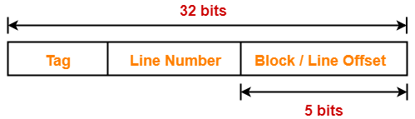

**Number of Bits in Line Number-**

 Total number of lines in cache= Cache size / Line size= 32 KB / 32 bytes= 210 lines

Thus, Number of bits in line number = 10 bits

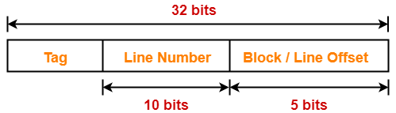

**Number of Bits Required For Cache Indexing-**

 Number of bits required for cache indexing= Number of bits in line number= 10 bits

**Number Of Bits in Tag-**

 Number of bits in tag= Number of bits in physical address – (Number of bits in line number + Number of bits in block offset)= 32 bits – (10 bits + 5 bits)= 32 bits – 15 bits= 17 bits

Thus, Number of bits in tag = 17 bits

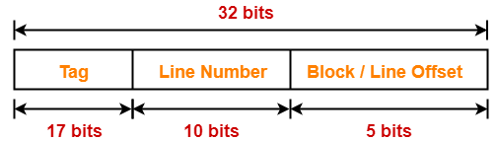

Thus, Option (A) is correct.

**Problem-05:**

Consider a machine with a byte addressable main memory of 232 bytes divided into blocks of size 32 bytes. Assume that a direct mapped cache having 512 cache lines is used with this machine. The size of the tag field in bits is ______.

**Solution-**

 Given-

* Main memory size = 232 bytes
* Block size = Frame size = Line size = 32 bytes
* Number of lines in cache = 512 lines

**Number of Bits in Physical Address-**

 We have,

Size of main memory= 232 bytes

Thus, Number of bits in physical address = 32 bits

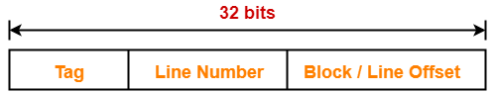

**Number of Bits in Block Offset-**

 We have,

Block size= 32 bytes= 25 bytes

Thus, Number of bits in block offset = 5 bits



**Number of Bits in Line Number-**

 Total number of lines in cache= 512 lines= 29 lines

Thus, Number of bits in line number = 9 bits

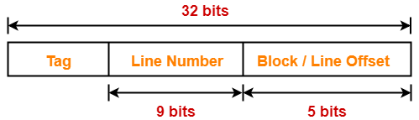

**Number Of Bits in Tag-**

 Number of bits in tag= Number of bits in physical address – (Number of bits in line number + Number of bits in block offset)= 32 bits – (9 bits + 5 bits)= 32 bits – 14 bits= 18 bits

Thus, Number of bits in tag = 18 bits

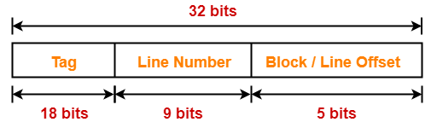

**Problem-06:**

 An 8 KB direct-mapped write back cache is organized as multiple blocks, each of size 32 bytes. The processor generates 32 bit addresses. The cache controller maintains the tag information for each cache block comprising of the following-

* 1 valid bit
* 1 modified bit
* As many bits as the minimum needed to identify the memory block mapped in the cache

What is the total size of memory needed at the cache controller to store meta data (tags) for the cache?

1. 4864 bits
2. 6144 bits
3. 6656 bits
4. 5376 bits

**Solution-**

Given-

* Cache memory size = 8 KB
* Block size = Frame size = Line size = 32 bytes
* Number of bits in physical address = 32 bits

**Number of Bits in Block Offset-**

We have,

Block size= 32 bytes= 25 bytes

Thus, Number of bits in block offset = 5 bits

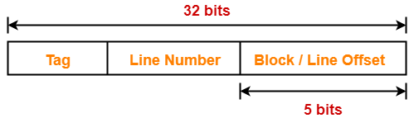

**Number of Bits in Line Number-**

 Total number of lines in cache= Cache memory size / Line size

= 8 KB / 32 bytes= 213 bytes / 25 bytes= 28 lines

Thus, Number of bits in line number = 8 bits

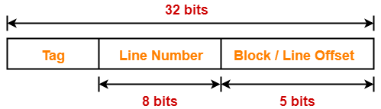

**Number Of Bits in Tag-**

 Number of bits in tag= Number of bits in physical address – (Number of bits in line number + Number of bits in block offset)= 32 bits – (8 bits + 5 bits)= 32 bits – 13 bits= 19 bits

Thus, Number of bits in tag = 19 bits

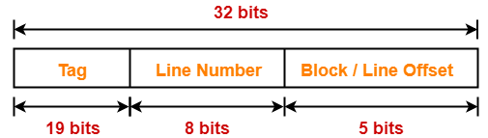

**Memory Size Needed At Cache Controller-**

 Size of memory needed at cache controller= Number of lines in cache x (1 valid bit + 1 modified bit + 19 bits to identify block)= 28 x 21 bits= 5376 bits

**Problem-01:**

Consider a fully associative mapped cache of size 16 KB with block size 256 bytes. The size of main memory is 128 KB. Find-

1. Number of bits in tag
2. Tag directory size

**Solution-**

 Given-

* Cache memory size = 16 KB
* Block size = Frame size = Line size = 256 bytes
* Main memory size = 128 KB

 We consider that the memory is byte addressable.

**Number of Bits in Physical Address-**

 We have,

Size of main memory= 128 KB= 217 bytes

Thus, Number of bits in physical address = 17 bits

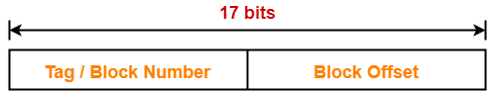

**Number of Bits in Block Offset-**

We have,

Block size= 256 bytes= 28 bytes

Thus, Number of bits in block offset = 8 bits

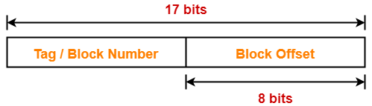

**Number of Bits in Tag-**

Number of bits in tag= Number of bits in physical address – Number of bits in block offset

= 17 bits – 8 bits= 9 bits

Thus, Number of bits in tag = 9 bits

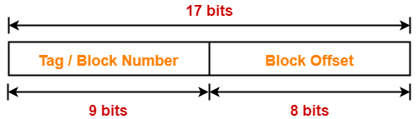

**Number of Lines in Cache-**

 Total number of lines in cache= Cache size / Line size

= 16 KB / 256 bytes= 214 bytes / 28 bytes= 26 lines

**Tag Directory Size-**

 Tag directory size= Number of tags x Tag size= Number of lines in cache x Number of bits in tag

= 26 x 9 bits= 576 bits= 72 bytes

Thus, size of tag directory = 72 bytes

**Problem-02:**

Consider a fully associative mapped cache of size 512 KB with block size 1 KB. There are 17 bits in the tag. Find-

1. Size of main memory
2. Tag directory size

**Solution-**

 Given-

* Cache memory size = 512 KB
* Block size = Frame size = Line size = 1 KB
* Number of bits in tag = 17 bits

 We consider that the memory is byte addressable.

**Number of Bits in Block Offset-**

 We have,

Block size= 1 KB= 210 bytes

Thus, Number of bits in block offset = 10 bits

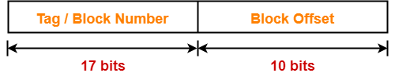

**Number of Bits in Physical Address-**

Number of bits in physical address= Number of bits in tag + Number of bits in block offset

= 17 bits + 10 bits= 27 bits

Thus, Number of bits in physical address = 27 bits

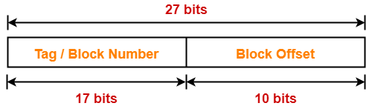

**Size of Main Memory-**

 We have,

Number of bits in physical address = 27 bits

Thus, Size of main memory= 227 bytes= 128 MB

**Number of Lines in Cache-**

Total number of lines in cache= Cache size / Line size= 512 KB / 1 KB= 512 lines= 29 lines

**Tag Directory Size-**

 Tag directory size= Number of tags x Tag size= Number of lines in cache x Number of bits in tag

= 29 x 17 bits= 8704 bits= 1088 bytes

Thus, size of tag directory = 1088 bytes

**Also Read-** [**Practice Problems On Set Associative Mapping**](https://www.gatevidyalay.com/set-associative-mapping-practice-problems/)

**Problem-03:**

Consider a fully associative mapped cache with block size 4 KB. The size of main memory is 16 GB. Find the number of bits in tag.

**Solution-**

Given-

* Block size = Frame size = Line size = 4 KB
* Size of main memory = 16 GB

We consider that the memory is byte addressable.

**Number of Bits in Physical Address-**

We have,

Size of main memory= 16 GB= 234 bytes

Thus, Number of bits in physical address = 34 bits

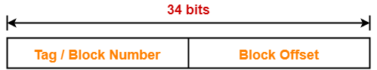

**Number of Bits in Block Offset-**

 We have,

Block size= 4 KB= 212 bytes

Thus, Number of bits in block offset = 12 bits

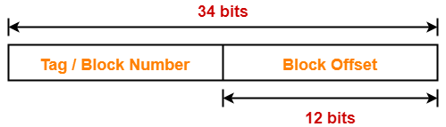

**Number of Bits in Tag-**

 Number of bits in tag= Number of bits in physical address – Number of bits in block offset

= 34 bits – 12 bits= 22 bits

Thus, Number of bits in tag = 22 bits

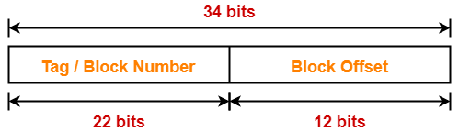

**PRACTICE PROBLEMS BASED ON SET ASSOCIATIVE MAPPING-**

**Problem-01:**

 Consider a 2-way set associative mapped cache of size 16 KB with block size 256 bytes. The size of main memory is 128 KB. Find-

1. Number of bits in tag
2. Tag directory size

**Solution-**

 Given-

* Set size = 2
* Cache memory size = 16 KB
* Block size = Frame size = Line size = 256 bytes
* Main memory size = 128 KB

We consider that the memory is byte addressable.

**Number of Bits in Physical Address-**

 We have,

Size of main memory= 128 KB= 217 bytes

Thus, Number of bits in physical address = 17 bits

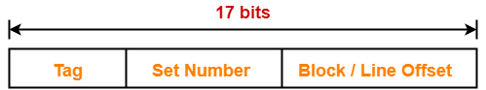

**Number of Bits in Block Offset-**

 We have,

Block size= 256 bytes= 28 bytes

Thus, Number of bits in block offset = 8 bits

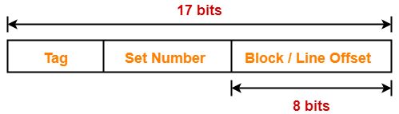

**Number of Lines in Cache-**

 Total number of lines in cache= Cache size / Line size

= 16 KB / 256 bytes= 214 bytes / 28 bytes= 64 lines

Thus, Number of lines in cache = 64 lines

**Number of Sets in Cache-**

Total number of sets in cache= Total number of lines in cache / Set size= 64 / 2= 32 sets=25 sets

Thus, Number of bits in set number = 5 bits

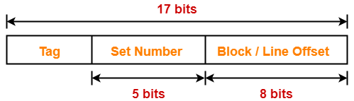

**Number of Bits in Tag-**

Number of bits in tag

= Number of bits in physical address – (Number of bits in set number + Number of bits in block offset)

= 17 bits – (5 bits + 8 bits)

= 17 bits – 13 bits

= 4 bits

Thus, Number of bits in tag = 4 bits

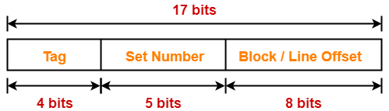

**Tag Directory Size-**

Tag directory size

= Number of tags x Tag size

= Number of lines in cache x Number of bits in tag

= 64 x 4 bits

= 256 bits

= 32 bytes

Thus, size of tag directory = 32 bytes

**Also Read-** [**Practice Problems On Direct Mapping**](https://www.gatevidyalay.com/direct-mapping-cache-practice-problems/)

**Problem-02:**

Consider a 8-way set associative mapped cache of size 512 KB with block size 1 KB. There are 7 bits in the tag. Find-

1. Size of main memory
2. Tag directory size

**Solution-**

Given-

* Set size = 8
* Cache memory size = 512 KB
* Block size = Frame size = Line size = 1 KB
* Number of bits in tag = 7 bits

We consider that the memory is byte addressable.

**Number of Bits in Block Offset-**

We have,

Block size= 1 KB= 210 bytes

Thus, Number of bits in block offset = 10 bits

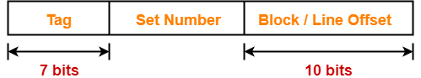

**Number of Lines in Cache-**

 Total number of lines in cache= Cache size / Line size= 512 KB / 1 KB= 512 lines

Thus, Number of lines in cache = 512 lines

**Number of Sets in Cache-**

 Total number of sets in cache= Total number of lines in cache / Set size= 512 / 8= 64 sets= 26 sets

Thus, Number of bits in set number = 6 bits

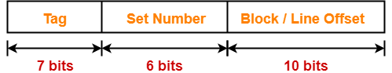

**Number of Bits in Physical Address-**

Number of bits in physical address= Number of bits in tag + Number of bits in set number + Number of bits in block offset= 7 bits + 6 bits + 10 bits= 23 bits

Thus, Number of bits in physical address = 23 bits

**Size of Main Memory-**

We have,

Number of bits in physical address = 23 bits

Thus, Size of main memory= 223 bytes= 8 MB

**Tag Directory Size-**

Tag directory size= Number of tags x Tag size= Number of lines in cache x Number of bits in tag

= 512 x 7 bits= 3584 bits= 448 bytes

Thus, size of tag directory = 448 bytes

**Problem-03:**

Consider a 4-way set associative mapped cache with block size 4 KB. The size of main memory is 16 GB and there are 10 bits in the tag. Find-

1. Size of cache memory
2. Tag directory size

**Solution-**

Given-

* Set size = 4
* Block size = Frame size = Line size = 4 KB
* Main memory size = 16 GB
* Number of bits in tag = 10 bits

We consider that the memory is byte addressable.

**Number of Bits in Physical Address-**

We have,

Size of main memory

= 16 GB

= 234 bytes

Thus, Number of bits in physical address = 34 bits

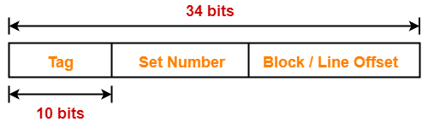

**Number of Bits in Block Offset-**

 We have,

Block size= 4 KB= 212 bytes

Thus, Number of bits in block offset = 12 bits

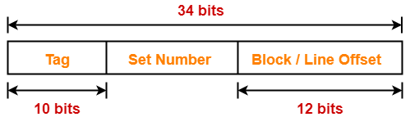

**Number of Bits in Set Number-**

 Number of bits in set number

= Number of bits in physical address – (Number of bits in tag + Number of bits in block offset)

= 34 bits – (10 bits + 12 bits)= 34 bits – 22 bits= 12 bits

Thus, Number of bits in set number = 12 bits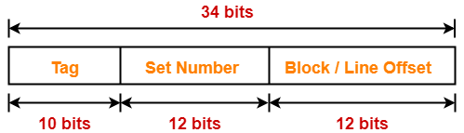

**Number of Sets in Cache-**

 We have-

Number of bits in set number = 12 bits

Thus, Total number of sets in cache = 212 sets

**Number of Lines in Cache-**

We have-

Total number of sets in cache = 212 sets

Each set contains 4 lines

Thus,

Total number of lines in cache= Total number of sets in cache x Number of lines in each set

= 212 x 4 lines= 214 lines

**Size of Cache Memory-**

Size of cache memory= Total number of lines in cache x Line size= 214 x 4 KB= 216 KB= 64 MB

Thus, Size of cache memory = 64 MB

**Tag Directory Size-**

Tag directory size= Number of tags x Tag size= Number of lines in cache x Number of bits in tag

= 214 x 10 bits= 163840 bits= 20480 bytes= 20 KB

Thus, size of tag directory = 20 KB

**Also Read-** [**Practice Problems On Fully Associative Mapping**](https://www.gatevidyalay.com/fully-associative-cache-practice-problems/)

**Problem-04:**

Consider a 8-way set associative mapped cache. The size of cache memory is 512 KB and there are 10 bits in the tag. Find the size of main memory.

**Solution-**

Given-

* Set size = 8
* Cache memory size = 512 KB
* Number of bits in tag = 10 bits

We consider that the memory is byte addressable.

Let-

* Number of bits in set number field = x bits
* Number of bits in block offset field = y bits

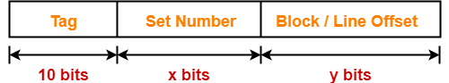

**Sum of Number Of Bits Of Set Number Field And Block Offset Field-**

We have,

Cache memory size = Number of sets in cache x Number of lines in one set x Line size

Now, substituting the values, we get-

512 KB = 2x x 8 x 2y bytes

219 bytes = 23+x+y bytes

19 = 3 +x + y

x + y = 19 – 3

x + y = 16

**Number of Bits in Physical Address-**

Number of bits in physical address= Number of bits in tag + Number of bits in set number + Number of bits in block offset= 10 bits + x bits + y bits= 10 bits + (x + y) bits= 10 bits + 16 bits= 26 bits

Thus, Number of bits in physical address = 26 bits

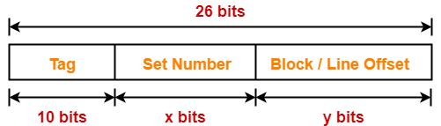

**Size of Main Memory-**

We have,

Number of bits in physical address = 26 bits

Thus, Size of main memory= 226 bytes= 64 MB

Thus, size of main memory = 64 MB

**Problem-05:**

 Consider a 4-way set associative mapped cache. The size of main memory is 64 MB and there are 10 bits in the tag. Find the size of cache memory.

**Solution-**

 Given-

* Set size = 4
* Main memory size = 64 MB
* Number of bits in tag = 10 bits

 We consider that the memory is byte addressable.

**Number of Bits in Physical Address-**

 We have,

Size of main memory= 64 MB= 226 bytes

Thus, Number of bits in physical address = 26 bits

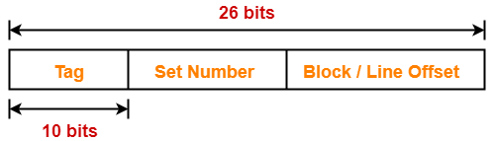

**Sum Of Number Of Bits Of Set Number Field And Block Offset Field-**

Let-

* Number of bits in set number field = x bits
* Number of bits in block offset field = y bits



Then, Number of bits in physical address

= Number of bits in tag + Number of bits in set number + Number of bits in block offset

So, we have-

26 bits = 10 bits + x bits + y bits

26 = 10 + (x + y)

x + y = 26 – 10

x + y = 16

Thus, Sum of number of bits of set number field and block offset field = 16 bits

**Size of Cache Memory-**

Cache memory size

= Number of sets in cache x Number of lines in one set x Line size

= 2x x 4 x 2y bytes= 22+x+y bytes= 22+16 bytes= 218 bytes= 256 KB

Thus, size of cache memory = 256 KB

